**Department of Electronics and Communication Central University of Rajasthan, Ajmer**



Signal and System Lab

Subject ...................................................................................................

ECE 214

Subject Code ...................................................................................................

2

111

Experiment No. .......................................................................................

Date:- - -2024

Roll no:- 2022BTECE012

Name:- Ojasvee Satija

**Title: -** To prove Maximum power Transfer Theorem using MATLAB

**Apparatus required:** - Downloaded MATLAB or OCTAVE software in device.

**Introduction:**- According to Maximum Power Theorem a resistance load, being connected to a dc network, receives maximum power when the load resistance is equal to the internal resistance (Thevenin's equivalent resistance) of the source network as seen from the load terminals

**Code:-**

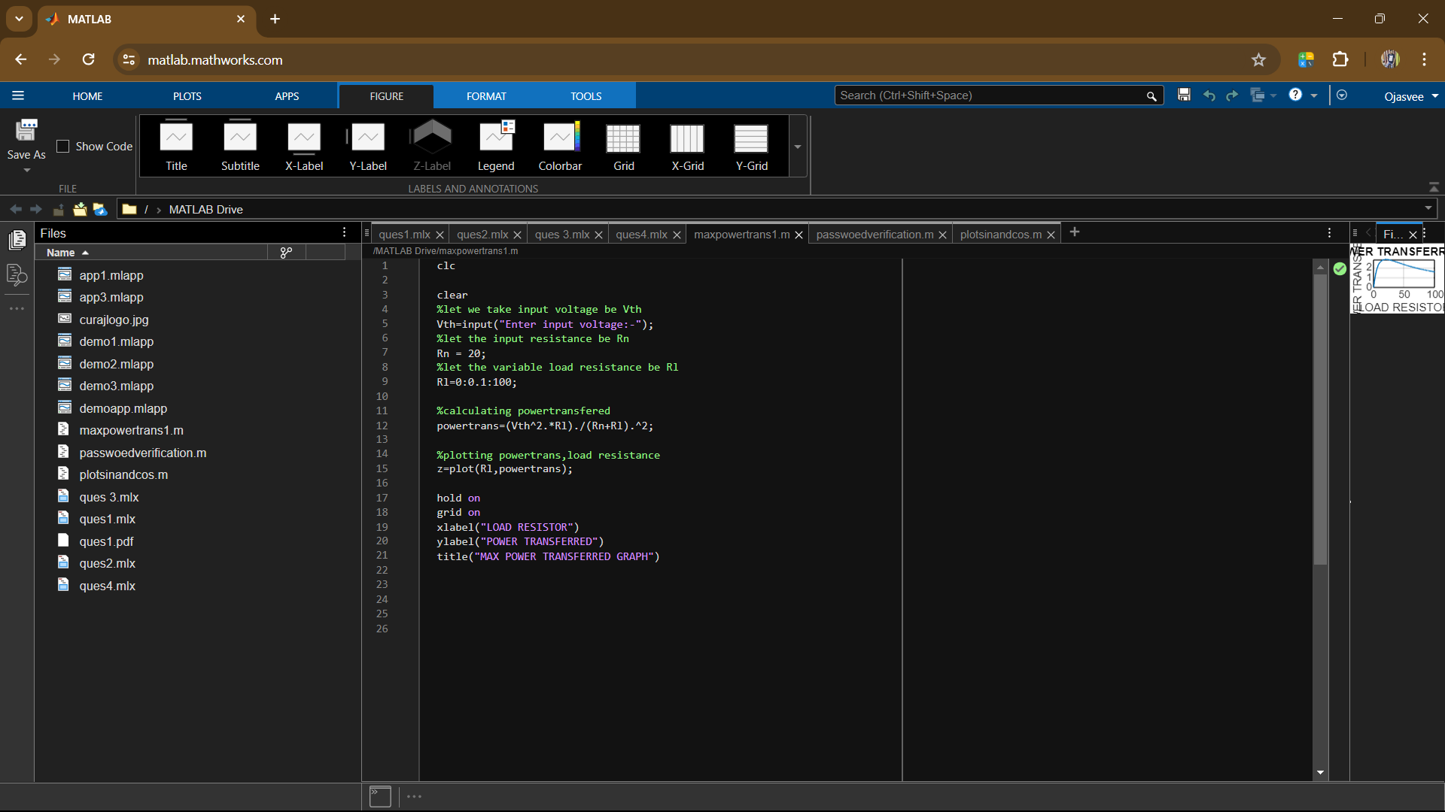

**Result:-**If input voltage is set to be 15 volt then the resultant graph is as under

